Submitted 18/12/2025 via StatsNZ webform

Public consultation form: Proposed data collection approach and content for the census
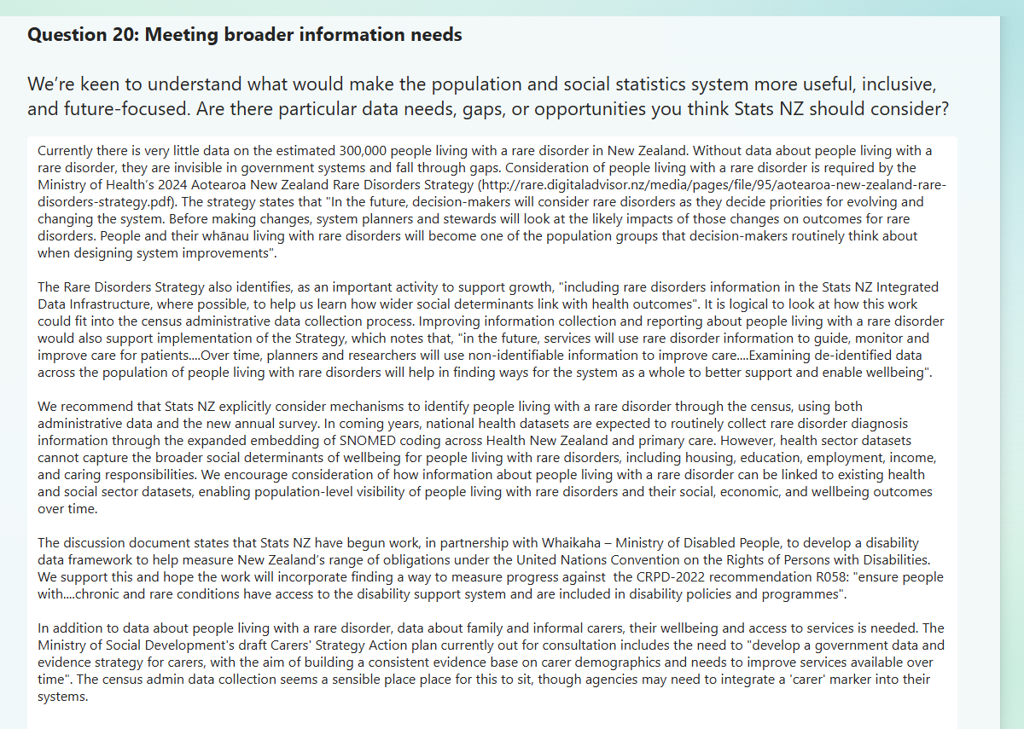

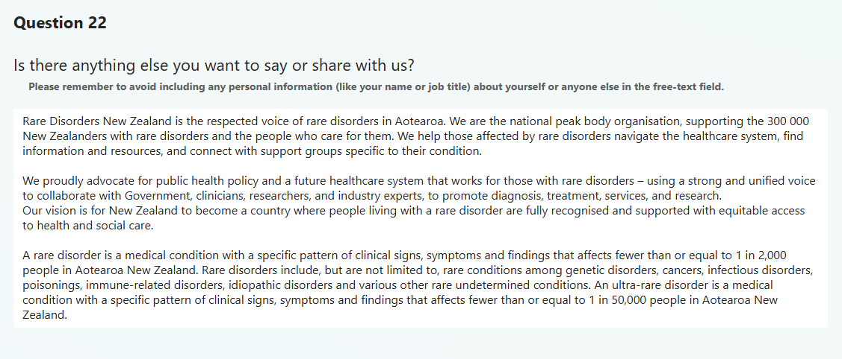

Rare Disorders New Zealand is the respected voice of rare disorders in Aotearoa. We are the national peak body organisation, supporting the 300 000 New Zealanders with rare disorders and the people who care for them. We help those affected by rare disorders navigate the healthcare system, find information and resources, and connect with support groups specific to their condition.
We proudly advocate for public health policy and a future healthcare system that works for those with rare disorders – using a strong and unified voice to collaborate with Government, clinicians, researchers, and industry experts, to promote diagnosis, treatment, services, and research.
Our vision is for New Zealand to become a country where people living with a rare disorder are fully recognised and supported with equitable access to health and social care.
A rare disorder is a medical condition with a specific pattern of clinical signs, symptoms and findings that affects fewer than or equal to 1 in 2,000 people in Aotearoa New Zealand. Rare disorders include, but are not limited to, rare conditions among genetic disorders, cancers, infectious disorders, poisonings, immune-related disorders, idiopathic disorders and various other rare undetermined conditions. An ultra-rare disorder is a medical condition with a specific pattern of clinical signs, symptoms and findings that affects fewer than or equal to 1 in 50,000 people in Aotearoa New Zealand.
Currently there is very little data on the estimated 300,000 people living with a rare disorder in New Zealand. Without data about people living with a rare disorder, they are invisible in government systems and fall through gaps. Consideration of people living with a rare disorder is required by the Ministry of Health’s 2024 Aotearoa New Zealand Rare Disorders Strategy (http://rare.digitaladvisor.nz/media/pages/file/95/aotearoa-new-zealand-rare-disorders-strategy.pdf). The strategy states that "In the future, decision-makers will consider rare disorders as they decide priorities for evolving and changing the system. Before making changes, system planners and stewards will look at the likely impacts of those changes on outcomes for rare disorders. People and their whānau living with rare disorders will become one of the population groups that decision-makers routinely think about when designing system improvements".
The Rare Disorders Strategy also identifies, as an important activity to support growth, "including rare disorders information in the Stats NZ Integrated Data Infrastructure, where possible, to help us learn how wider social determinants link with health outcomes". It is logical to look at how this work could fit into the census administrative data collection process. Improving information collection and reporting about people living with a rare disorder would also support implementation of the Strategy, which notes that, "in the future, services will use rare disorder information to guide, monitor and improve care for patients....Over time, planners and researchers will use non-identifiable information to improve care....Examining de-identified data across the population of people living with rare disorders will help in finding ways for the system as a whole to better support and enable wellbeing".
We recommend that Stats NZ explicitly consider mechanisms to identify people living with a rare disorder through the census, using both administrative data and the new annual survey. In coming years, national health datasets are expected to routinely collect rare disorder diagnosis information through the expanded embedding of SNOMED coding across Health New Zealand and primary care. However, health sector datasets cannot capture the broader social determinants of wellbeing for people living with rare disorders, including housing, education, employment, income, and caring responsibilities. We encourage consideration of how information about people living with a rare disorder can be linked to existing health and social sector datasets, enabling population-level visibility of people living with rare disorders and their social, economic, and wellbeing outcomes over time.
The discussion document states that Stats NZ have begun work, in partnership with Whaikaha – Ministry of Disabled People, to develop a disability data framework to help measure New Zealand’s range of obligations under the United Nations Convention on the Rights of Persons with Disabilities. We support this and hope the work will incorporate finding a way to measure progress against the CRPD-2022 recommendation R058: "ensure people with....chronic and rare conditions have access to the disability support system and are included in disability policies and programmes".

In addition to data about people living with a rare disorder, data about family and informal carers, their wellbeing and access to services is needed. The Ministry of Social Development's draft Carers' Strategy Action plan currently out for consultation includes the need to "develop a government data and evidence strategy for carers, with the aim of building a consistent evidence base on carer demographics and needs to improve services available over time". The census admin data collection seems a sensible place place for this to sit, though agencies may need to integrate a 'carer' marker into their systems

