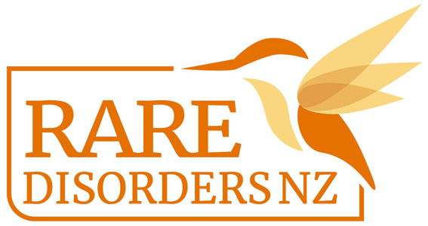

**Media release template |Rare Disorders Month Support Group Kit**

**MEDIA RELEASE**

[Insert date]

[Insert logo]

[For immediate release/Or embargo]

**[Insert support group name] Rallies Community for Rare Disorders Month**

[Insert support group name] is kicking into action for the return of Rare Disorders Month and encouraging its community and Aotearoa to Glow Up and Show Up for rare.

Rare Disorders Month is an advocacy and support period starting on International Rare Disease Day, 28 February, and running through the month of March.

As a support and advocacy group for one of 7,000+ rare disorders in Aotearoa, [Insert support group name] hopes it can help to bring rare disorders like [insert rare disorder] out of the darkness, and into the light, says [Insert spokesperson]..

“It’s not rare to have a rare disorder. In Aotearoa, more than 300,000 people live with one of 7,000 rare disorders. Now is our chance for [insert organisation name] and the entire rare disorder community to rally together.

“Let’s light the way for rare.”

During the month, Aotearoa is being called to Glow up and Show up for Rare via community events like colour runs and morning teas, social media campaigning, and a Rare Beer challenge with Fortune Favours.

[Insert spokesperson name] says that the [insert rare disorder] community and its whānau and supporters can show support by sharing social media posts, donating to the Rare Disorders NZ [Givealittle page](https://givealittle.co.nz/org/rare-disorders-nz#:~:text=Rare%20Disorders%20NZ%20is%20the%20only%20umbrella%20group%20for%20rare,around%206%25%20of%20the%20population.), and engaging in #GlowUpShowUp community events. [Also include any details about events your organisation is hosting, or ways people can support your organisation during the month].

Rare Disorders NZ Chief Executive Chris Higgins says that as it stands in New Zealand, people living with rare disorders feel invisible in our healthcare system.

“For 25 years, Rare Disorders NZ (RDNZ) and the rare community have been working hard to rally Aotearoa and the Government to do right by rare. After more than two decades of advocacy, last year the Government delivered NZ’s first Rare Disorders Strategy. But since then, progress on its implementation has slowed. For 1 in 5 people with a rare disorder, it took over 10 years to get a diagnosis. While we celebrate 25 years of progress, the rare community can’t wait for action any longer.”

Together we can bring rare disorders out of the darkness, and into the light. Together we can show up and achieve impactful change.”

More information about rare disorders and Rare Disorders Month, including how to get involved, can be found at raredisorders.org.nz or @raredisorders_nz. Visit [insert your website] to learn more about [insert rare disorder type] and support the [insert rare disorder type] community during Rare Disorders Month.

#GlowUpShowUp  
#RareDisordersMonth

#DoRightByRare

ENDS

[Include contact information and a short bio about your organisation in the editor’s notes below the media release. You may also like to include a link to your media kit with images, spokesperson bios, and more information about Rare Disorders Month.]