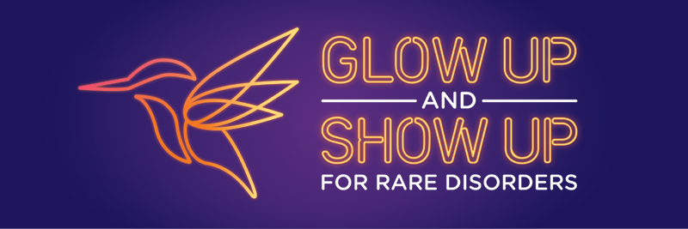

**Newsletter template |Rare Disorders Month Workplaces Kit**

March is Rare Disorders Month, a support period for the rare disorder community where Aotearoa is being called to Glow Up and Show Up for rare.

At [insert organisation name], we’re proud to have been getting stuck into #GlowUpShowUp by [insert activities here].

[Provide details and photos from activities and events.]

Together we’ve raised [$X] for Rare Disorders NZ – the collective voice supporting those living with rare disorders in Aotearoa. Huge thanks to everyone who helped us to Glow Up and Show Up by getting involved and donating.

It’s not rare to have a rare disorder. The rare community is over 300,000 strong. If you don’t live with a rare disorder yourself, you probably know someone who does.

For 25 years, Rare Disorders NZ (RDNZ) and the rare community have been working hard to rally Aotearoa and the Government to do right by rare. After more than two decades of advocacy, last year the Government delivered NZ’s first Rare Disorders Strategy. But since then, progress on its implementation has slowed. While we celebrate 25 years of progress, the rare community can’t wait for action any longer.

Through highlighting this issue, raising money and maintaining visibility, together we can bring rare disorders out of the darkness, and into the light. Together we can show up and achieve impactful change.

Visit raredisorders.org.nz, or follow @RareDisorders_NZ on Facebook, Instagram, and LinkedIn to see more on how to get involved in Rare Disorders Month.