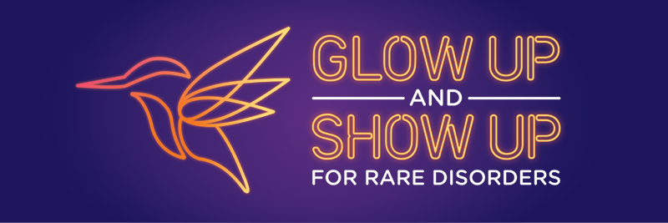

**Newsletter template |Rare Disorders Month Support Group Kit**

[Choose images from our library [here](https://drive.google.com/drive/folders/1TfXy2d8kQgoM3eeA2Wrmfb7abQUN9QPj?usp=share_link)]

March is Rare Disorders Month, a support period for the rare disorder community where Aotearoa is being called to Glow Up and Show Up for rare.

This month is a chance for [insert organisation name] to come together with other rare disorder communities and use our collective voices to raise meaningful awareness.

At [Insert support group name], we’ve been getting stuck into #GlowUpShowUp by [insert activities here].

[Provide details and photos from activities and events.]

Together we’ve raised [$X] for Rare Disorders NZ – the collective voice supporting and advocating for those living with rare disorders in Aotearoa. Huge thanks to everyone who helped us to Glow Up and Show Up by getting involved and donating.

It’s not rare to have a rare disorder. The rare community is over 300,000 strong. If you don’t live with a rare disorder yourself, you probably know someone who does.

For 25 years, Rare Disorders NZ and the rare community have been working hard to rally Aotearoa and the Government to do right by rare. After more than two decades of advocacy, last year the Government delivered New Zealand’s first Rare Disorders Strategy. But since then, progress on its implementation has slowed. While we celebrate 25 years of progress, the rare community can’t wait for action any longer.

This Rare Disorders Month is a chance to keep up the momentum and continue to Glow Up and Show Up. It’s time to celebrate our progress while calling for the Strategy to be implemented. Let’s light the way for rare.

Through highlighting this issue, raising money and maintaining visibility, together we can bring rare disorders like [insert rare disorder and 7,000 more] out of the darkness, and into the light.

It can be hard to know how to support someone with a rare disorder. But often, the best thing to do is just #ShowUp.

Visit raredisorders.org.nz, or follow @RareDisorders_NZ on Facebook, Instagram, LinkedIn and Twitter to see more on how to get involved in Rare Disorders Month.